**What is Bank.**

A Bank is a financial Institution licensed to receive deposits & make loan. In most countries, banks are regulated by the National government or central bank.

**Different Type of Banking**

1. **Retails Banking** – Dealing Directly with the Individual & small business. (Grade A)
2. **Business Banking** – Providing Services to Mid-Market Business. (Grade B)
3. **Corporate Banking** – Directed at large Business Entities. (Grade C)
4. **Private Banking** – Providing wealth service to High-Net worth individuals & families.
5. **Investment Banking** – Relating to activities to the financial Market.

**Compliance**

Compliance in Banking is the process of following the rule, laws & regulation that apply to the financial industry. Compliance helps banks avoid legal or regulatory sanctions, Financial Loss, or reputation damage.

Some examples of compliance are.

* Data Security
* Anti Money Laundering
* Risk Assessment & Management A key part of banking compliance is understanding the problems that laws and regulations are intended to address.

**What is Money Laundering**

Money laundering is the process by which one conceals the existence, illegal source or illegal application of income to make it appear as legitimate.

In other word it is a process used by criminal through which they make “dirty” money appear “clean”

**What is Anti Money Laundering**

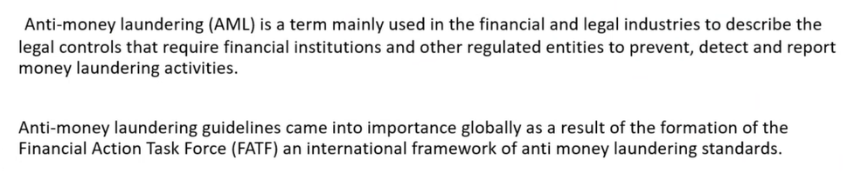

**Thress stages in Money Laundering cycle**

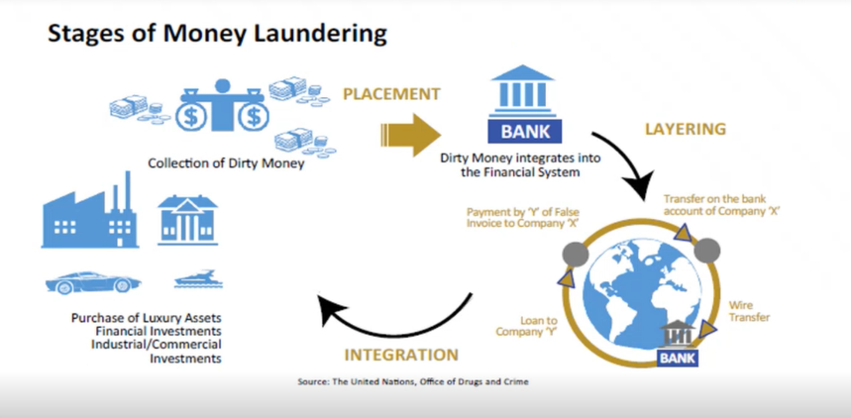

**Source of Money Laundering**

* Arms & weapons Trafficking
* Drug Trafficking
* Human Trafficking
* Illegal Gambling
* Corruption
* Contract Killing
* Tax Evasion
* Prostitution

**Predicate Offence** Unlawful activity whose proceeds, if involved in the transaction, can give rise to prosecution for the crime of money laundering.

**Money laundering & Globalization**

**Penalties paid by Financial Institution**

**Combating the Financing of Terrorism**

**What is EDD ?**

EDD, to put it simply, was created as a set of rules and procedures to deal with high-risk clients and significant financial transactions.

**PEP** will fall under EDD.

**What is PEP**

A Politically Exposed Person (PEP) is someone who, through their position or influence, is more susceptible to being involved in bribery, money laundering or corruption.

Example: -

Salary Person – Low Risk (Review will be after 20 years)

Real Estate – Mid Risk (Review will be after 10 years)

EDD Customer – High Risk (Review will be after 5 years)